Grammar
Grades K-3, 10:15-10:45 a.m. Wednesdays 2017-18
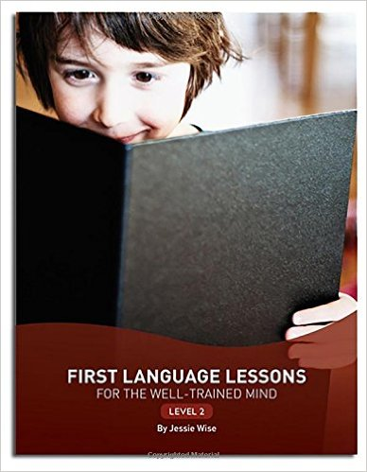
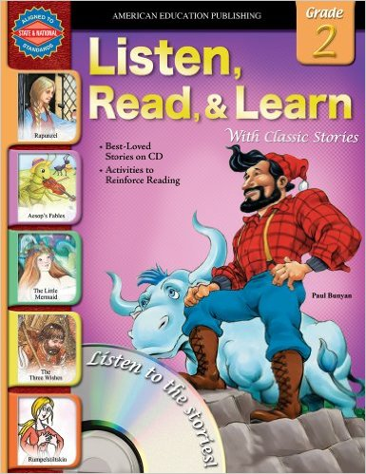

Description: This course will use an oral grammar lesson course by Jessie Wise, Level 2, which covers grades 2-4. By imitation and repetition, students come to understand nouns, pronouns, verbs, capitalization, verb states, linking verbs, sentence types, commas, helping verbs, contractions, adjectives, and additional review of these grammar concepts. We will also use appropriate material from the Listen, Read and Learn series, Level 3 to incorporate more grammar exercises for reinforcement and variation.
Heather Williams is a Suzuki piano teacher and Music Together center director with a degree from Brigham Young University in Piano with over 20 years of teaching experience in private and group lessons. She has taught Grammar for 4 years to homeschool students. She currently teaches piano lessons in Fair Oaks and El Dorado Hills and directs Music Together in Fair Oaks and Citrus Heights. She has 4 small children, ages 10, 8, 6 and 2 1/2.
Monthly Class Fee (13 weeks) Total: $18.75

