History
Grades K-3, 9:15-10:15 a.m. Wednesdays 2017-18
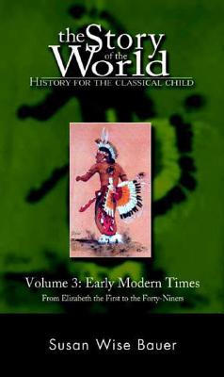
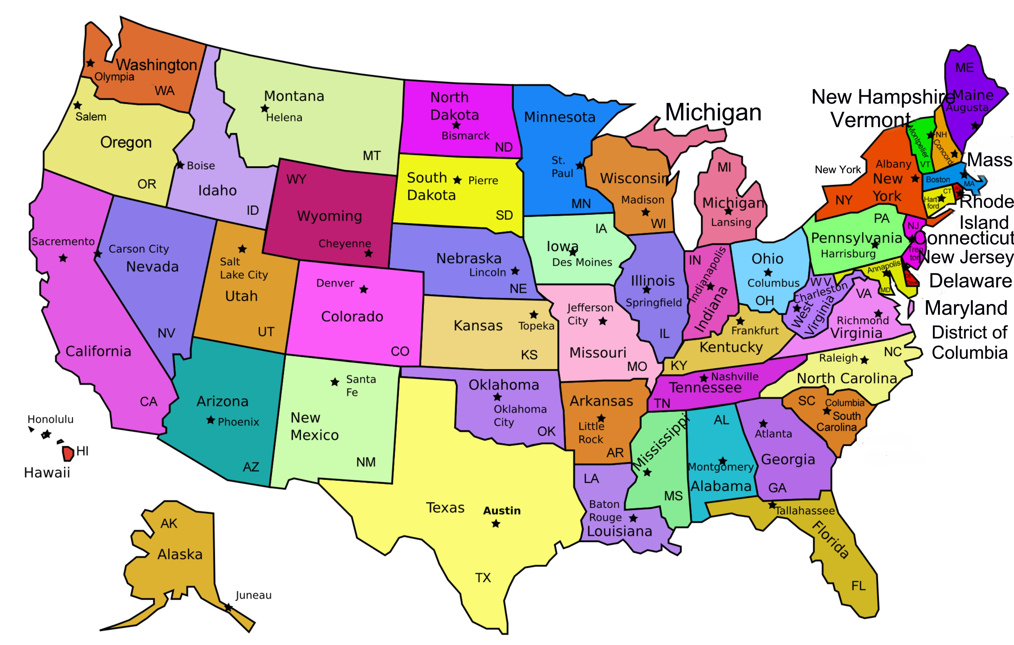
California
3rd Grade Social Study Standards

Description: This course covers California Social Studies Standards for 3rd grade with modified work samples for younger grades. Students in grade three learn more about our connections to the past and the ways in which particularly local, but also regional and national, government and traditions have developed and left their marks on current society, providing common memories. Emphasis is on the physical and cultural landscape of California, including the study of American Indians, the subsequent arrival of immigrants, and the impact they have had in forming the character of our contemporary society. We will also study the three branches of government, the importance of public virtue and the role of citizens, the histories of important local and national landmarks, symbols and essential documents that create a sense of community among citizens, the ways in which California, the other states, and sovereign American Indian tribes contribute to the making of our nation and describe the lives of Americans who took risks to secure our freedoms. We will also cover parts of the Story of World Vol. 3: Early Modern Times, which covers Elizabeth the First to the Forty-Niners. Using pictures, stories, supplemental videos and activities, children will get a basic introduction to these stories. The CD series is highly recommended for parents and children to enjoy at home or in travel.
Heather Williams is a Suzuki piano teacher and Music Together center director with a degree from Brigham Young University in Piano with over 20 years of teaching experience in private and group lessons. She has taught History for 4 years to homeschool students. She currently teaches piano lessons in Fair Oaks and El Dorado Hills. She has 4 small children, ages 10, 8, 6 and 2 ½.

Monthly Class Fee: $43.75 (13 weeks) Total: $175

